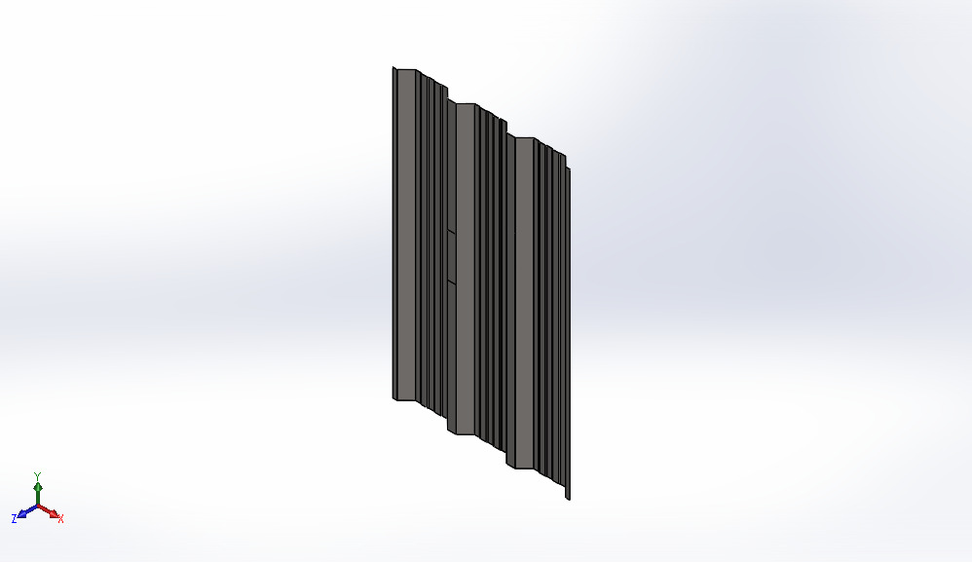
  Simulation of Sheet v1[1].step
  Date: Monday, January 1, 2024
  Designer: Solidworks
  Study name: Static 2
  Analysis type: Static
  Table of Contents
  Units 2
  Material Properties 2
  Loads and Fixtures 3
  Resultant Forces 4
  Study Results 5

Units
Unit system: | SI (MKS)
Length/Displacement | mm
Temperature | Kelvin
Angular velocity | Rad/sec
Pressure/Stress | N/m^2

Material Properties
Model Reference | Properties | Components
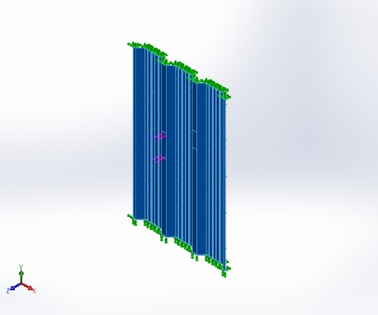 |  | SolidBody 1(Split Line2)(Sheet v1[1].step)
  Name: | Plain Carbon Steel
  Model type: | Linear Elastic Isotropic
  Default failure criterion: | Max von Mises Stress
  Yield strength: | 2.20594e+08 N/m^2
  Tensile strength: | 3.99826e+08 N/m^2
  Elastic modulus: | 2.1e+11 N/m^2
  Poisson's ratio: | 0.28
  Mass density: | 7,800 kg/m^3
  Shear modulus: | 7.9e+10 N/m^2
  Thermal expansion coefficient: | 1.3e-05 /Kelvin
Curve Data:N/A

Loads and Fixtures
Fixture name | Fixture Image | Fixture Details
Fixed-1 | 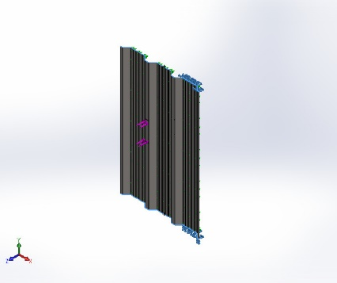
  Entities: | 2 face(s)
  Type: | Fixed Geometry
Resultant Forces
Components | X | Y | Z | Resultant
Reaction force(N) | 4.29153e-05 | 0.000384331 | -0.334005 | 0.334006
Reaction Moment(N.m) | 0 | 0 | 0 | 0

Roller/Slider-2 | 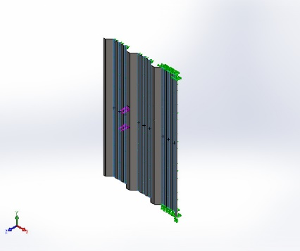
  Entities: | 9 face(s)
  Type: | Roller/Slider
Resultant Forces
Components | X | Y | Z | Resultant
Reaction force(N) | 16.3693 | -12.5554 | 1,023.87 | 1,024.08
Reaction Moment(N.m) | 0 | 0 | 0 | 0

Load name | Load Image | Load Details
Force-1 | 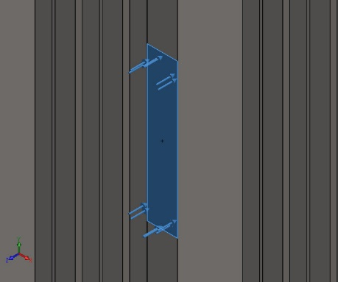
  Entities: | 1 face(s)
  Type: | Apply normal force
  Value: | 1,000 N

Resultant Forces

Reaction forces
Selection set | Units | Sum X | Sum Y | Sum Z | Resultant
Entire Model | N | 4.29153e-05 | 0.000384331 | 1,000 | 1,000

Reaction Moments
Selection set | Units | Sum X | Sum Y | Sum Z | Resultant
Entire Model | N.m | 0 | 0 | 0 | 0

Free body forces
Selection set | Units | Sum X | Sum Y | Sum Z | Resultant
Entire Model | N | 0.000164579 | 0.000279006 | 4.17233e-05 | 0.000326606

Free body moments
Selection set | Units | Sum X | Sum Y | Sum Z | Resultant
Entire Model | N.m | 0 | 0 | 0 | 1e-33

Study Results

Name | Type | Min | Max
Stress1 | VON: von Mises Stress | 3.396e+04N/m^2  Node: 23258 | 3.438e+07N/m^2  Node: 22623
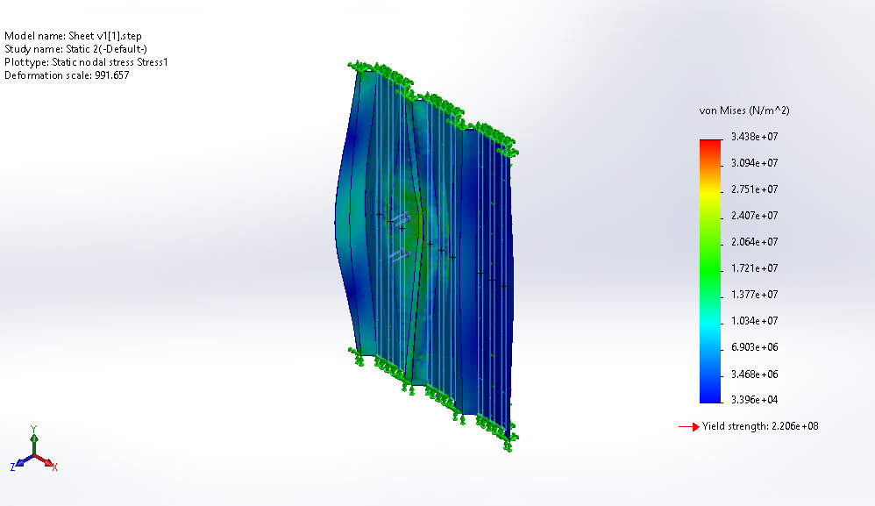
Sheet v1[1].step-Static 2-Stress-Stress1

Name | Type | Min | Max
Displacement1 | URES: Resultant Displacement | 0.000e+00mm  Node: 2 | 1.009e-01mm  Node: 31579
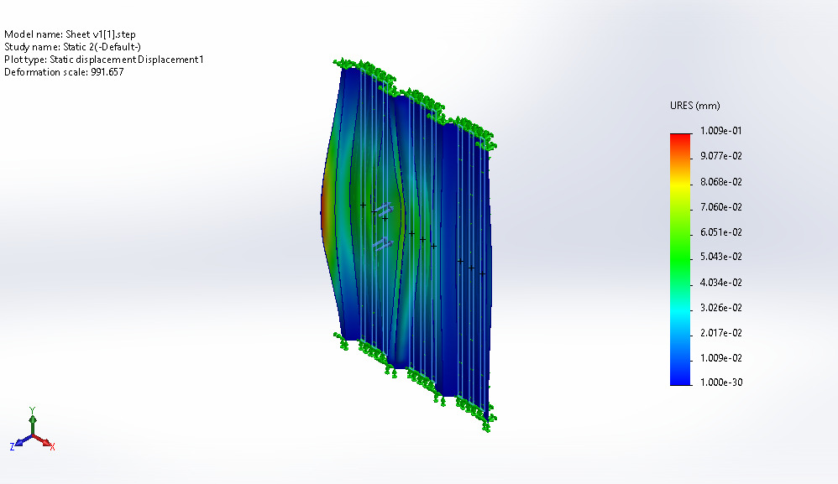
Sheet v1[1].step-Static 2-Displacement-Displacement1

Name | Type | Min | Max
Strain1 | ESTRN: Equivalent Strain | 1.934e-07  Element: 15964 | 1.051e-04  Element: 15772
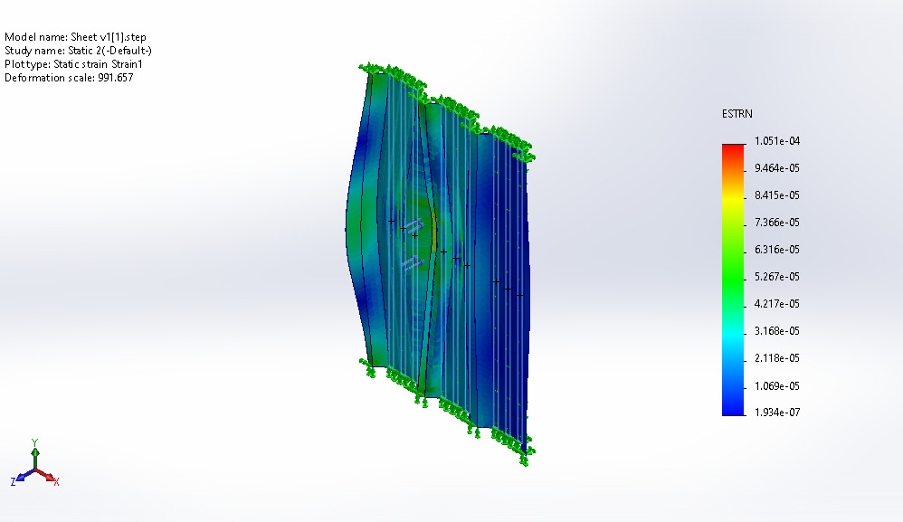
Sheet v1[1].step-Static 2-Strain-Strain1

